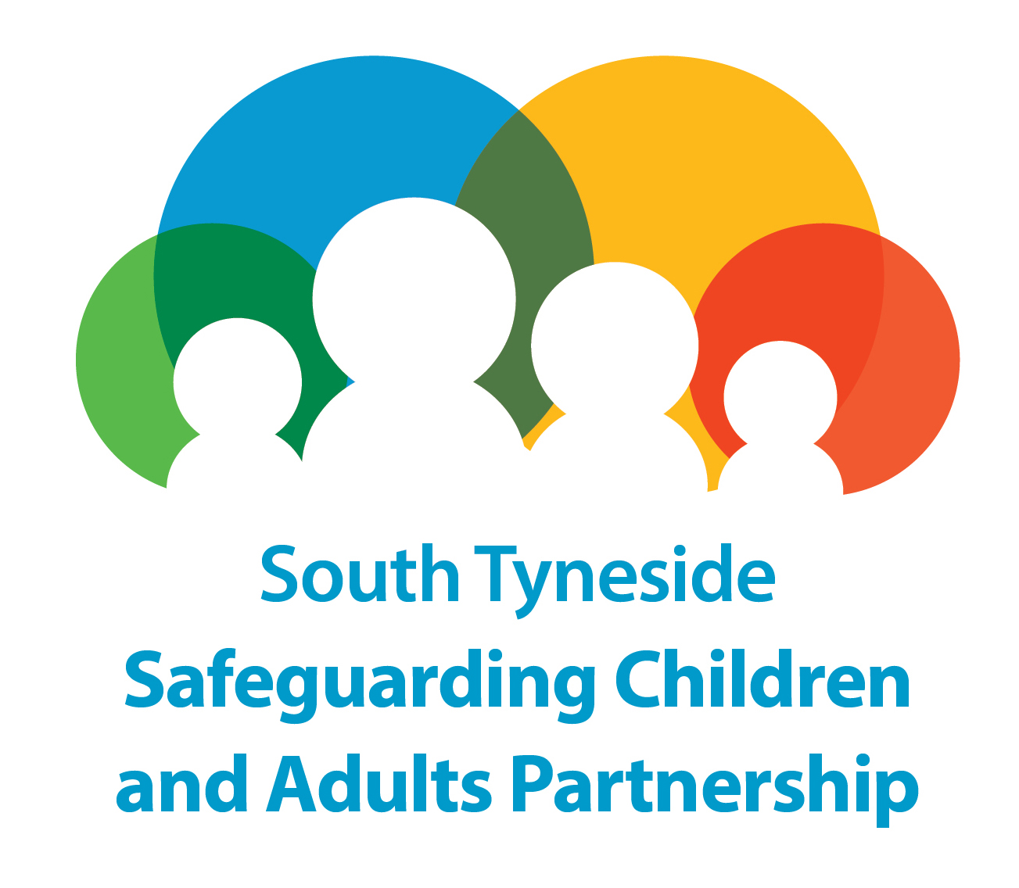

Safeguarding Adults in South Tyneside
MANAGING SAFEGUARDING CONCERNS AT AN ORGANISATIONAL LEVEL

Note: This agenda is not an exhaustive list and the chair or other members of the meeting can add items as required. It is not expected that the organization will attend this meeting. However, if they are in attendance the chair should consider whether they are asked to leave for part of the meeting.

Item No | Subject
1. | Welcome and Introductions  - Is there a conflict of interest for any of the invitees
2. | Confidentiality Statement
3. | Purpose of the Meeting and the Agenda
4. | Information Specific to the Organisation: Identify and Clarify Concerns
5. | Consultation Strategy: Service Users, Family and Friends
6. | Organisational Risk Assessment and Mitigation
7. | Involvement of Other Agencies including out of area
8. | Consideration of the Need to Suspend or Remove Adults At Risk
9. | Reviews – Local Authority, Clinical Commissioning Group or Other
10. | Communications and Timescales
11. | Date of Next Meeting: To Be Set

