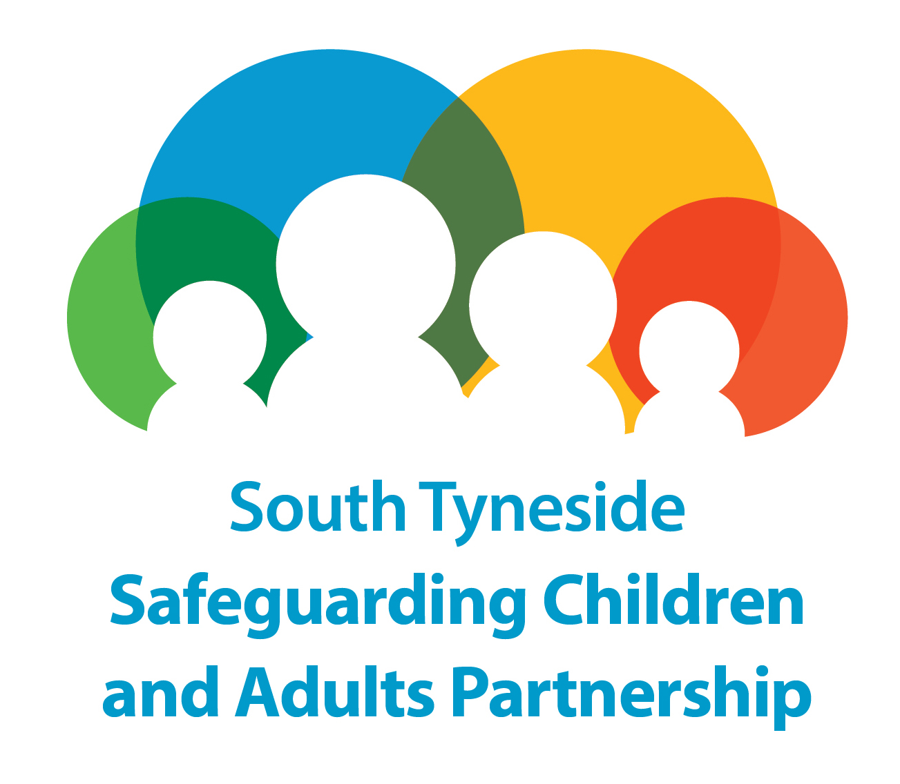

Safeguarding Adults in South Tyneside
MANAGING SAFEGUARDING CONCERNS AT AN ORGANISATIONAL LEVEL

GUIDANCE

Note: This agenda is not an exhaustive list and the Chair or other members of the meeting can add items as required.

Item No | Subject
1. | Welcome and Introductions  As well as introducing themselves it is helpful if everybody present explains their role at the beginning of the meeting. This meeting should be attended by senior members of the organization in question.  - Is there a conflict of interest for any of the invitees: i.e. personal relationships between any member of the Managing Safeguarding Enquiries at an Organisational level group and any person(s) implicated in the concerns that may compromise the process.
2. | Confidentiality Statement  To be read out at the meeting by the Chair.  Information shared in this meeting is strictly confidential and any information breaches should be brought to the attention of the chair for further discussion and action. This meeting is being held under the South Tyneside Multi-agency Safeguarding Adults Policies and Procedures - Managing Safeguarding Concerns At An Organisational Level Procedure.  All information shared in this meeting should not be discussed outside of the meeting unless  agreed by the chair . Attendees are likely to disclose a range of issues and exchange information  for the prevention and detection of crime and/or to identity any risks of harm. The minutes may be used at a later date for other relevant investigations, for example, in police, DBS (Disclosure and Barring Service) or other investigations. The attendees agree to store all minutes securely and in  line with their own information governance protocols and agreements. This meeting will be  informed by a commitment to equal opportunities.  The Chair should clarify at this point who information is being shared with as part of the Managing Safeguarding Concerns at an Organisational Level Procedure.
3. | Purpose of the Meeting and the Agenda  At this point as this is the first meeting the organisational concerns process should be explained, with a clear emphasis on partnership working to improve the quality of services to residents.
4. | Feedback from Organisational Concerns Meeting  This should include as much information as possible, including all the identified risks and potential risks. Protective measures and what the organisation is expected to do to protect resident’s friends and family. The organisation should be informed that instigation of the organisational concerns process is an extremely serious step for the LA to take and that regular update reports will be shared with the Commissioner, Directors and Members. It should be noted again that the LA intention is work with the organization where possible in an open and transparent manner that facilitates improved quality of care and that feedback from the organsiation is also welcomed and encouraged.
5. | Feedback from Organsiation  This is the opportunity for the organization to comment on the progress of the improvement plan and concerns raised.
6. | Organisation Users ,Friends, Family & Advocacy Agreement  The chair should be clear that contact between the organization safeguarding concerns meeting group and users of the organisation , residents’ friends and family and advocacy services are a vital part of the process, agreement should be reached on meetings and correspondence
7. | Further Actions and Communication Strategy  The meeting should set out what further actions are being taken by the organization safeguarding concerns group where this can be shared and expectations in terms of the organisation improvement plan.

