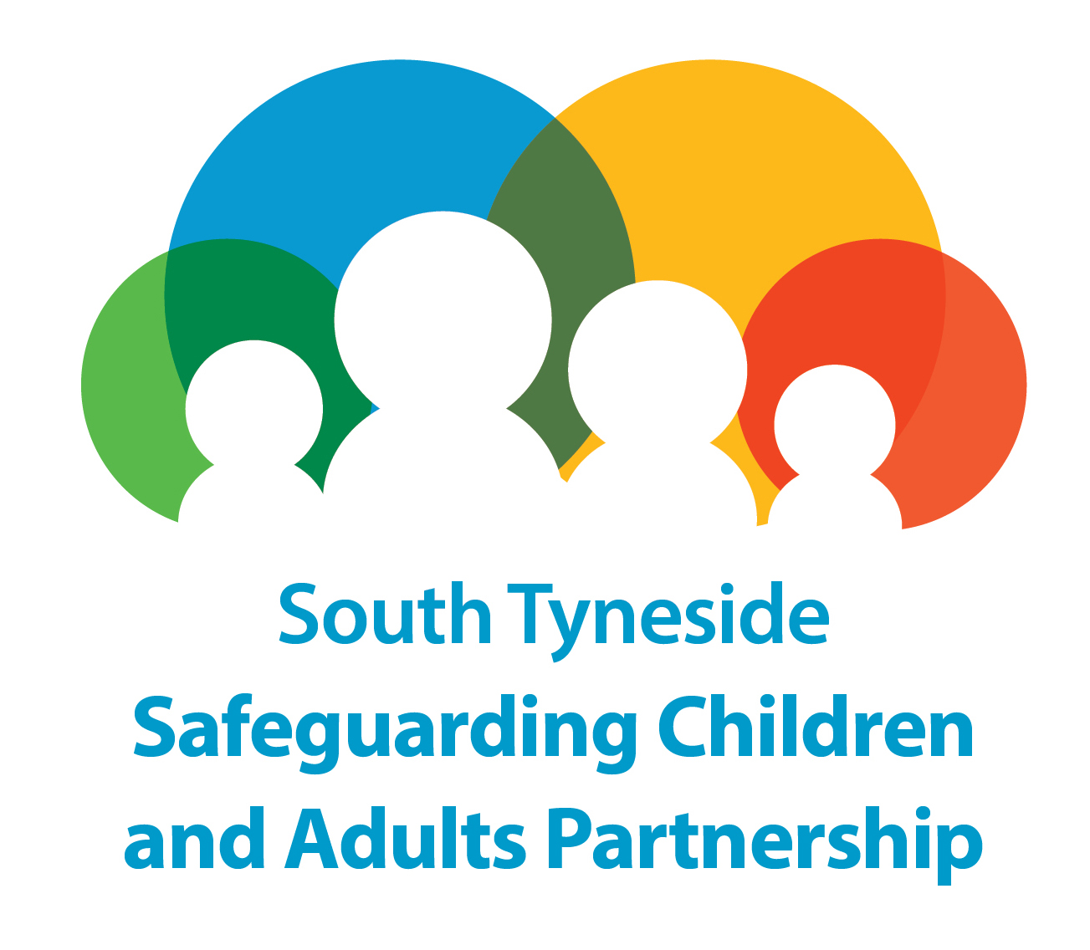

Safeguarding Adults in South Tyneside
MANAGING SAFEGUARDING CONCERNS AT AN ORGANISATIONAL LEVEL
– GUIDANCE

Note: This agenda is not an exhaustive list and the Chair or other members of the meeting can add items as required.

Item No | Subject
1. | Welcome and introductions  As well as introducing themselves it is helpful if everybody present explains their role at the beginning of the meeting. This meeting should be attended by senior members of the organization in question.  - Is there a conflict of interest for any of the invitees: i.e. personal relationships between any member of the organizational concerns group and any person(s) implicated in the concerns that may compromise the process
2. | Confidentiality Statement – To be read out at the meeting by the Chair  Information shared in this meeting is strictly confidential and any information breaches should be brought to the attention of the Chair for further discussion and action. This meeting is being held under the Care Act and the South Tyneside Safeguarding Adults multi agency policies and procedures -Managing Safeguarding Concerns at an Organisational Level .  All information shared in this meeting should not be discussed outside the meeting unless agreed by the Chair. Attendees are likely to disclose a range of issues and exchange information for the prevention or detection of crime and/or to identify any risks of harm. These minutes may be used at a later date for example, in Police, the Disclosure and Barring Service or other investigations. The attendees agree to store all minutes securely. This meeting will be informed by a commitment to equal opportunities.
3. | Purpose of the meeting and the agenda  Explain why this meeting has been called under the Managing Safeguarding Concerns at an Organisational Level policy and in order to provide update and feedback from the organisational concerns meeting group.
4. | Feedback from Meeting - Managing Safeguarding Concerns at an Organisational Level  This should include as much information as possible, including all the identified risks and potential risks. Protective measures and what the organization is expected to do to protect those involved with the organization , resident’s friends and family. The organisation should be informed that instigation of the Managing Safeguarding Concerns at an Organisational l Level is an extremely serious step for the LA to take and that regular update reports will be shared with the Commissioner, Directors and Members. It should be noted again that the LA intention is work with the organisation where possible in an open and transparent manner that facilitates improved quality of care and that feedback from the organisation is also welcomed and encouraged.
5. | Feedback from Organisation  This is the opportunity for the organization to comment on the progress of the improvement plan and concerns raised.
6. | Service Users Friends, Family and Advocacy Agreement  The chair should be clear that contact between the organizational safeguarding concerns meeting group and residents’ friends, family and advocacy services are a vital part of the process, agreement should be reached on meetings and correspondence
7. | Further Actions and Communication Strategy  The meeting should set out what further actions are being taken by the organizational safeguarding concerns meeting group where this can be shared and expectations in terms of the service improvement plan.

