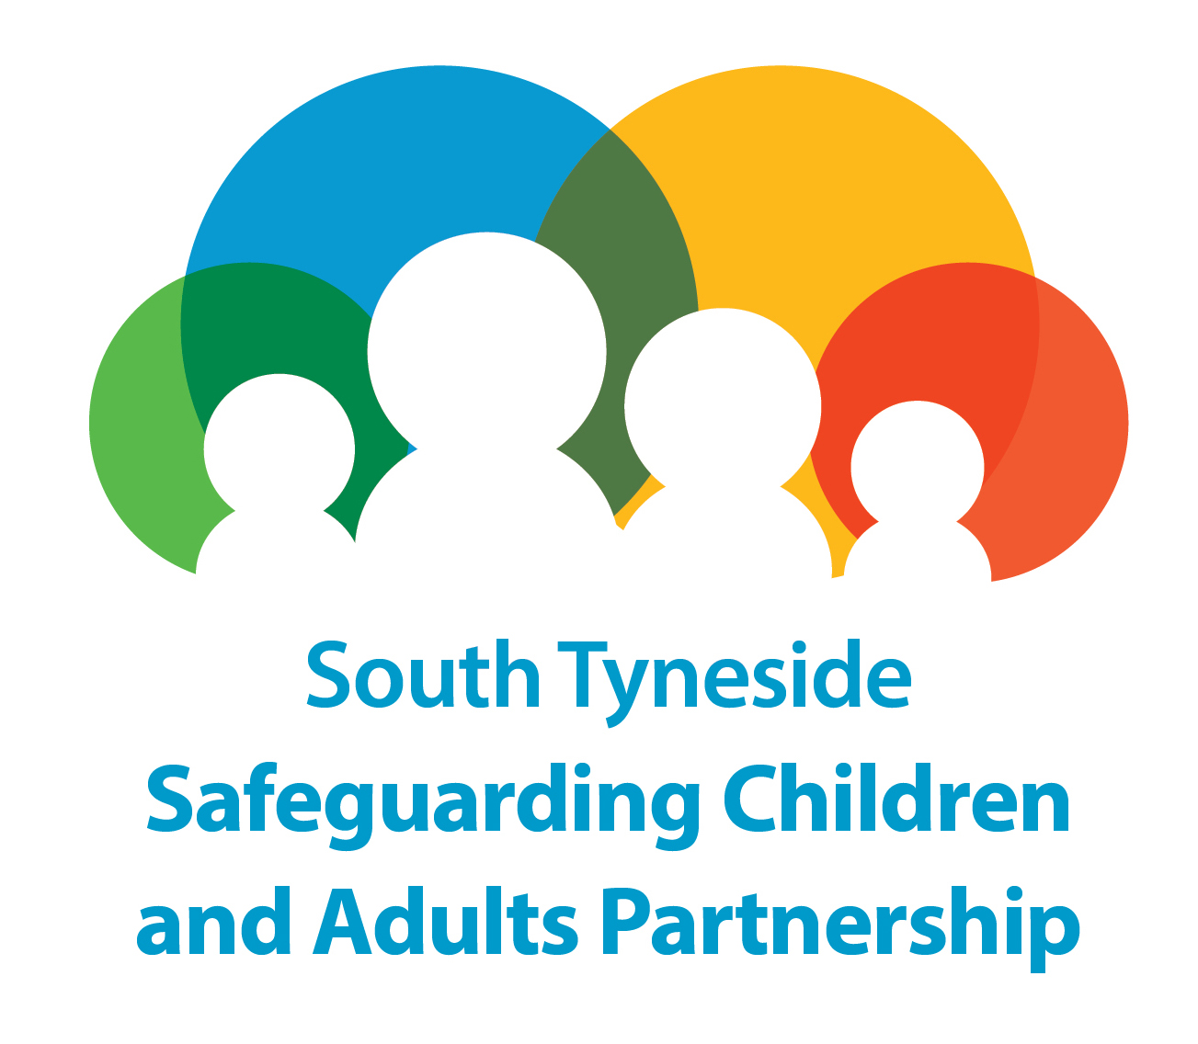

Safeguarding Adults in South Tyneside
MANAGING SAFEGUARDING CONCERNS AT AN ORGANISATIONAL LEVEL
MEETING AGENDA

Note: This agenda is not an exhaustive list and the Chair or other members of the meeting can add items as required.

Item No | Subject
1. | Welcome and Introductions
2. | Confidentiality Statement
3. | Purpose of the Meeting and the Agenda
4. | Feedback from Organisation Safeguarding Concerns Meeting
5. | Feedback from Organisation
6. | Organisation Users Friends and Family and Advocacy Agreement
7. | Further Actions and Communication Strategy

