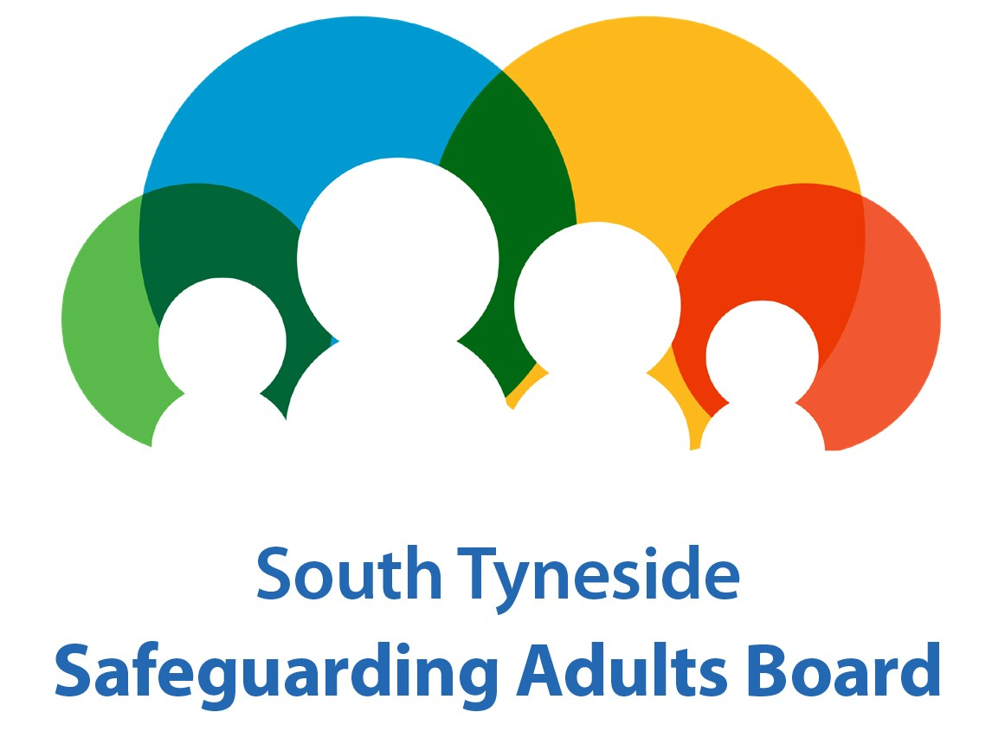

**MULTI-AGENCY SAFEGUARDING ADULTS REFERRAL FORM**

This form must be completed to refer an adult safeguarding concern to the local authority under the Care Act 2014. All Provider organisations should refer to the South Tyneside Safeguarding Adults Board Organisational Procedures to determine which procedural framework applies – quality or safeguarding.

The form should not replace taking any immediate action to safeguard a person. If a response is needed the same day, please contact the Let’s Talk Team:

Monday to Thursday, 8.30am to 5.00pm – 0191 424 6000

Friday, 8.30am to 4.30pm – 0191 424 6000

Outside of the above hours please contact the Out of Hours Service on 0191 456 2093.

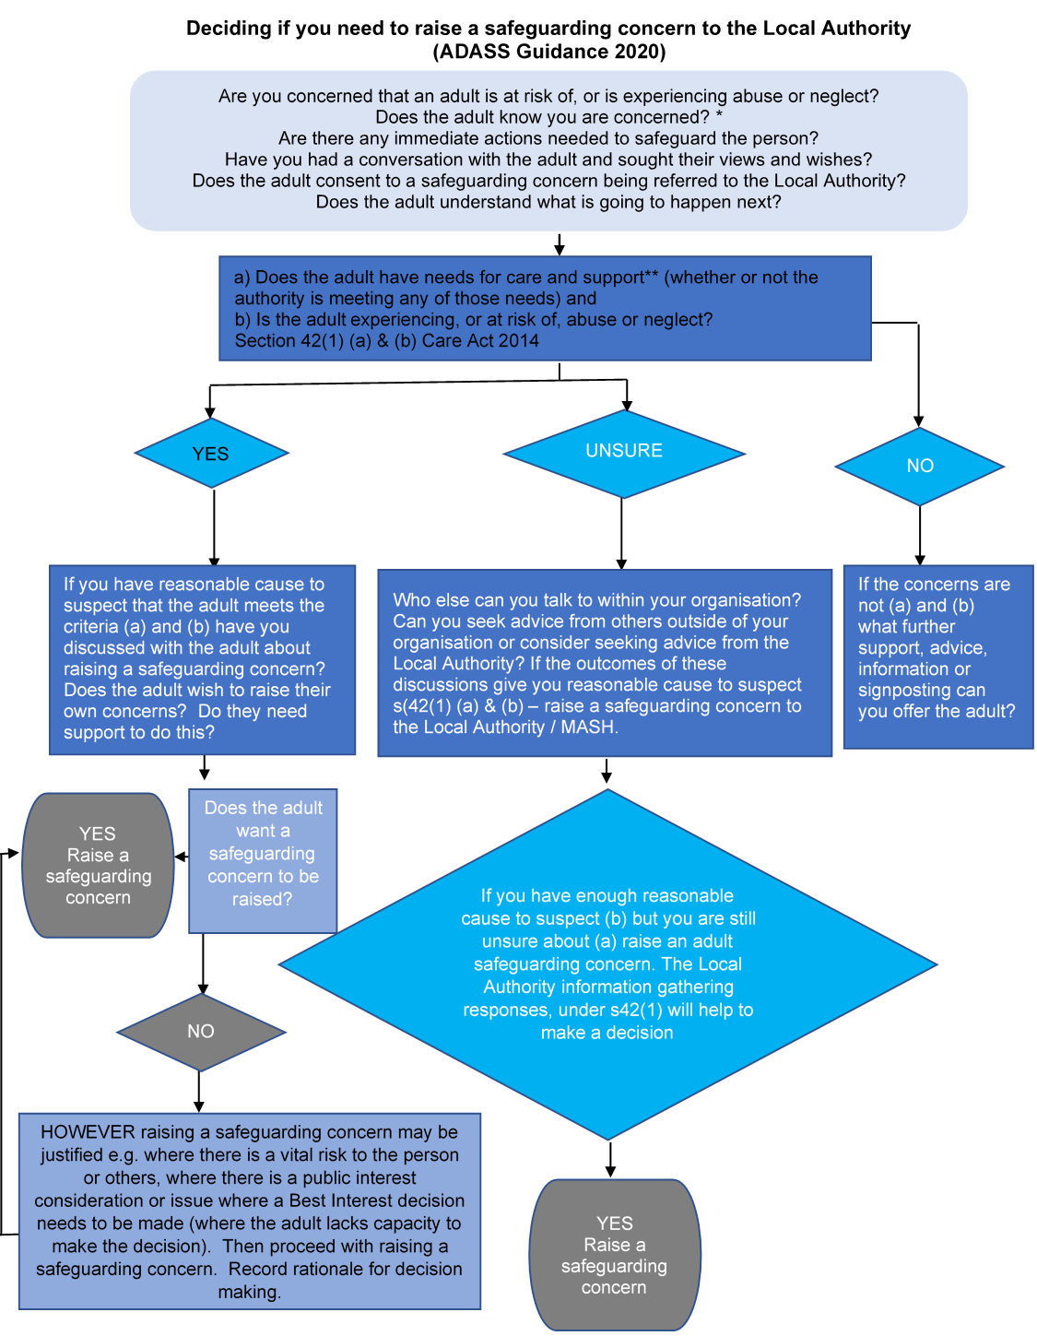

**\*** There may be circumstances where the safety of the adult or yourself prevent this from happening. If you still have concerns about abuse or neglect and it is not possible or within the scope of your role to have a conversation with the adult, then if in doubt continue with the process and raise a safeguarding concern. This does not mean the professional can be an anonymous referrer.

** Care and support needs are focused on supporting an adult to maintain their independence, enabling them to play a fuller part in society, helping them to manage complex relationships and positively manage risk.

**The Referral Form**

|  |  |
| --- | --- |
| **Under the Care Act 2014 Safeguarding Adult duties apply to:**  An adult aged 18 or over:   1. Who has needs for care and support (whether or not the local authority is meeting any of those needs) and; 2. Is experiencing, or at risk of, abuse or neglect; and 3. as a result of those care and support needs is unable to protect themselves from either the risk of, or the experience of abuse or neglect. | |
| **Does (a) and (b) of the adult safeguarding duty apply to this concern?** | Please Select |
| **If yes, please describe the adults care and support needs including any information about any care provision in place if known.** | |
| ***If no – do not complete this form as safeguarding duties do not apply. If you still have concerns about an adult you should follow your organisations procedures.*** | |

|  |  |  |  |
| --- | --- | --- | --- |
| **DETAILS OF THE ADULT AT RISK OF ABUSE** | | | |
| **Name** |  | | |
| **Date of Birth** |  | | |
| **Address** |  | | |
| **Telephone Number** |  | | |
| **Gender** |  | | |
| **Ethnicity** | Choose an item. | | |
| **GP Practice** |  | | |
| **Is the adult aware of the referral?** | Please Select | | **If No, please explain why:** |
| **Has the adult consented to the referral?** | Please Select | **If no, please explain why:**  *Lack of consent should not prevent a safeguarding concern being submitted. However, referrers* ***must*** *provide a rationale and justification for overriding a person’s wishes* | |
| **What are the adult’s wishes regarding this referral?** |  | | |
| **Does the adult have any communication needs?** | Please Select | **If yes, please give details:** | |

|  |  |
| --- | --- |
| **DESCRIBE THE DETAILS OF THE ALLEGED ABUSE / RISK OF ABUSE**  **Please give as much detail as possible relating to the concerns** | |
| **Date abuse occurred** | Click here to enter a date. |
| **Who was involved?** |  |
| **What happened?** |  |
| **Where did it happen?** |  |
| **How do the care and support needs described above mean the person is unable to protect themselves from either the risk of, or the experience of, abuse or neglect?** |  |
| **Are there any concerns for the person’s safety?** | Please Select |
| **If yes, please detail what action has been taken:** | |
| **Is it believed a criminal offence has been committed?** | Please Select |
| **If Yes, have the Police been contacted?** | Please Select |
| **If Yes, please give crime number** |  |
| **Categories of alleged abuse** | Choose an item. |
| **If more than one alleged category of abuse please state additional categories:** | |
| **Is anyone else at risk at this address?** | Please Select |
| **Are there any other adults residing at this address?** | Please Select |
| **If Yes, please give details:** | |
| **Are there any children residing at this address?** | Please Select |
| **If Yes, please give details – names and dates of birth, if known:** | |
| **Do you have any concerns about the child/children’s safety and welfare?** | Please Select |
| **If Yes, please provide details and what action has been taken to date:** | |

|  |  |
| --- | --- |
| **DETAILS OF ALLEGED PERPETRATOR** | |
| **Name** |  |
| **Relationship to alleged victim** | Choose an item. |
| **Address and telephone number of alleged perpetrator** |  |
| **Is the alleged perpetrator a Person in a Position of Trust?** | Please Select |
| **If Yes, please provide details:** | **Organisation:**  **Address:**  **Telephone Number:** |
| **Have any immediate HR actions been taken about the alleged perpetrator?** | Please Select |

|  |  |
| --- | --- |
| **DETAILS OF THE PERSON SUBMITTING THE CONCERN** | |
| **Name** |  |
| **Designation / Role** |  |
| **Agency / Organisation** |  |
| **Address** |  |
| **Telephone** |  |
| **Email Address** |  |
| **Is it secure?** | Please Select |
| **Alternative contact person if the referrer is not available:** | **Name:**  **Telephone number:**  **E-mail:** |
| **Date form completed** | Click here to enter a date. |

**Please send the completed form by secure email to:**

[**Safeguardingadults@southtyneside.gov.uk**](mailto:Safeguardingadults@southtyneside.gov.uk)

**If you do not have a secure email account please email** [**letstalk@southtyneside.gov.uk**](mailto:letstalk@southtyneside.gov.uk) **or telephone the Let’s Talk Team (0191 424 6000) and request secure email link is sent to you prior to submitting the form.**

**Once submitted you will receive an automatic e-mail to confirm receipt into the Safeguarding Inbox. If you don’t receive an e-mail, please telephone Let’s Talk Team to confirm receipt.**